The living room is a place in a residential house for relaxing and socializing. Is usually located in front of the door.
The living room can be used as library, game room, movie room, photo gallery and music room.
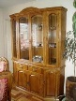
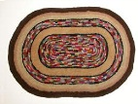
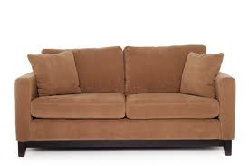
Some items of the living room are:

sofa rug glassware
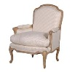
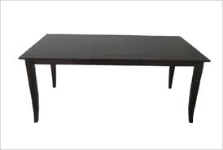
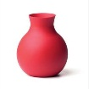

coffee table armchair vase
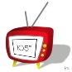
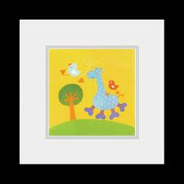


television telephone picture
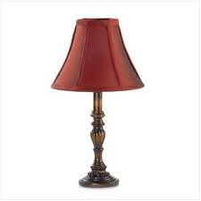
lamp

